isselbacher gallery
64 East 86th Street, New York, NY 10028 917-509-7833 isselbacherart@aol.com

IFPDA Fine Art Print Fair, March 2022

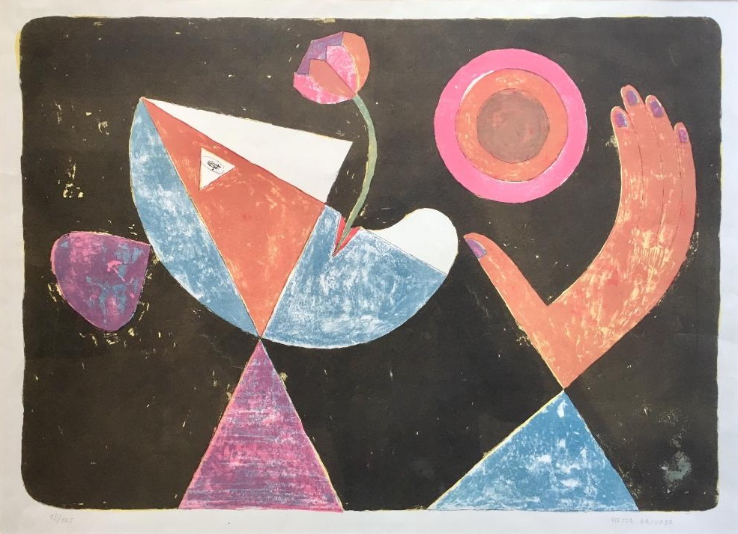
Victor BRAUNER (1903-1966) La La La La Fiancée heliotropique
Lithograph, printed in color, on wove paper, 1955
One of 125 signed and numbered examples
Published by L’Oeuvre Gravée, Paris, with
their blindstamp in the margin
Image size: 15 3/8 x 21 7/8 inches

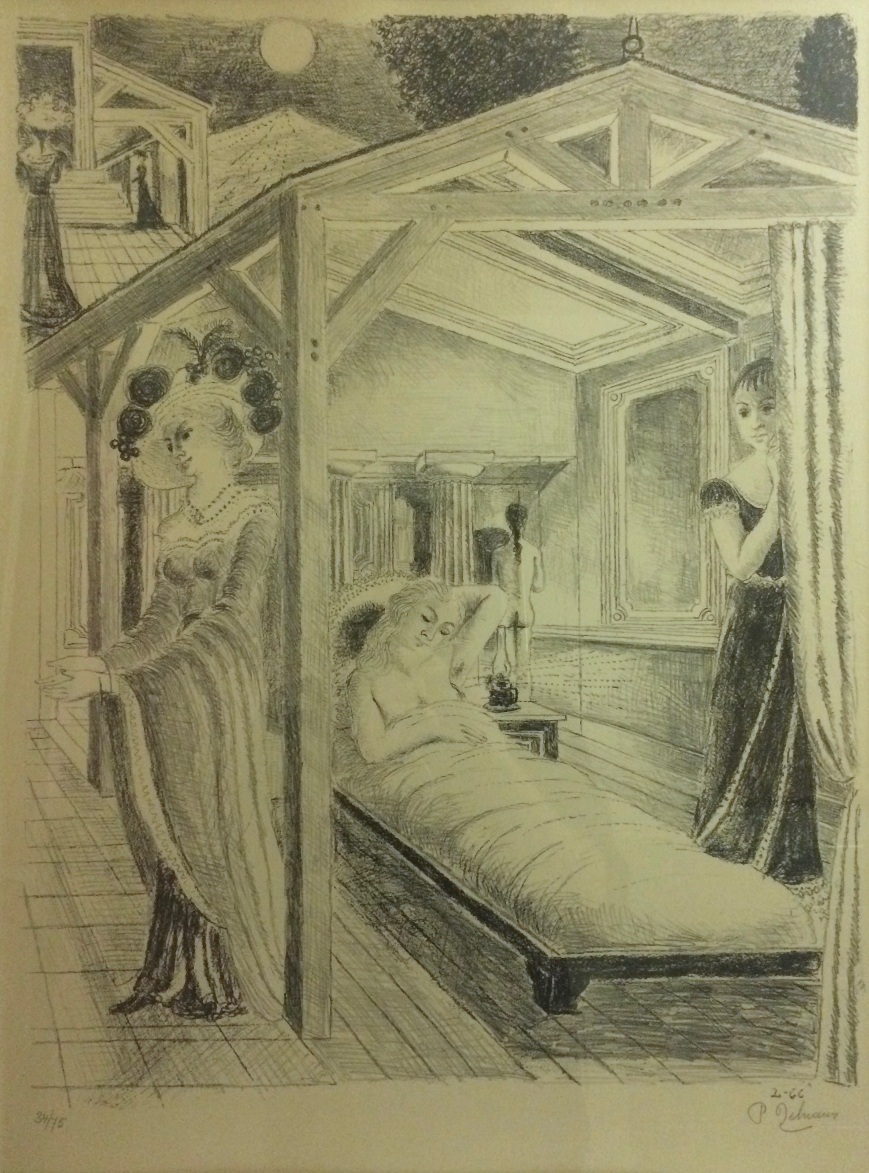
Paul DELVAUX (1897-1994)
La Mer est proche
Lithograph, printed in black on Arches paper, 1966
One of 75 signed and numbered examples
Published by Galerie Le Bateau Lavoir, Paris
Image size: 25 ½ x 20 inches
Reference: Jacob 8

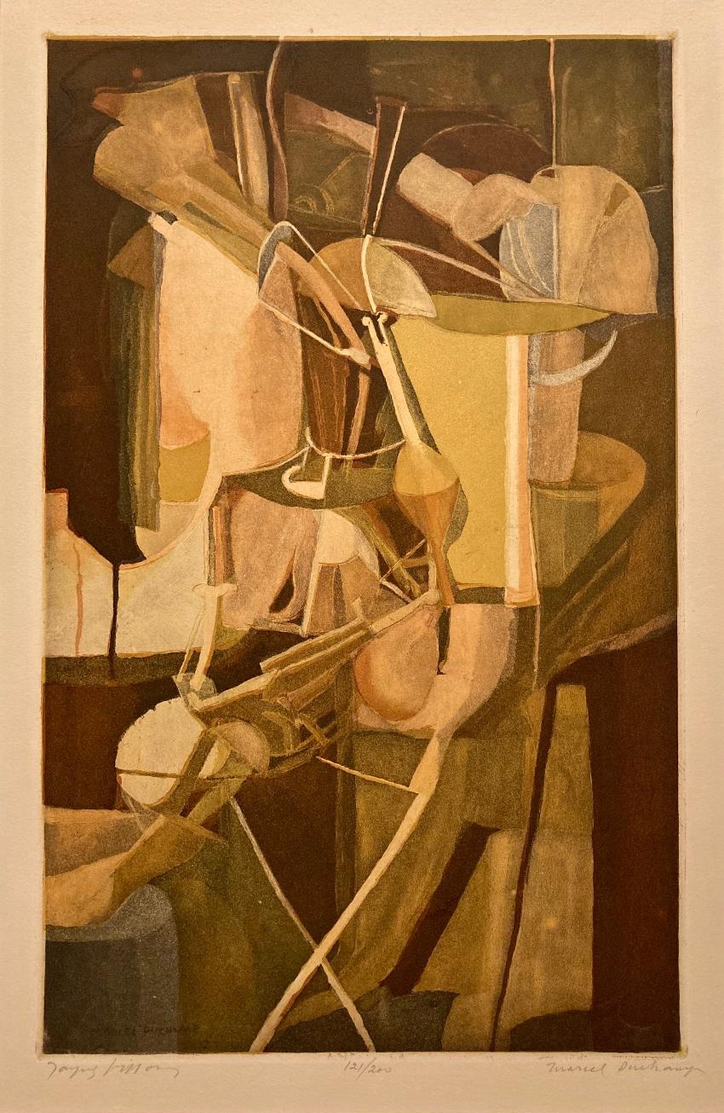

Marcel DUCHAMP (1887-1968)
La Mariée
Aquatint, engraved by his brother, Jacques Villon, and
printed in color on wove paper, 1934
One of 200 examples signed by both Duchamp
and Villon
Image size: 19 ½ x 12 ¼ inches
Reference: Ginestet & Pouillon E 672

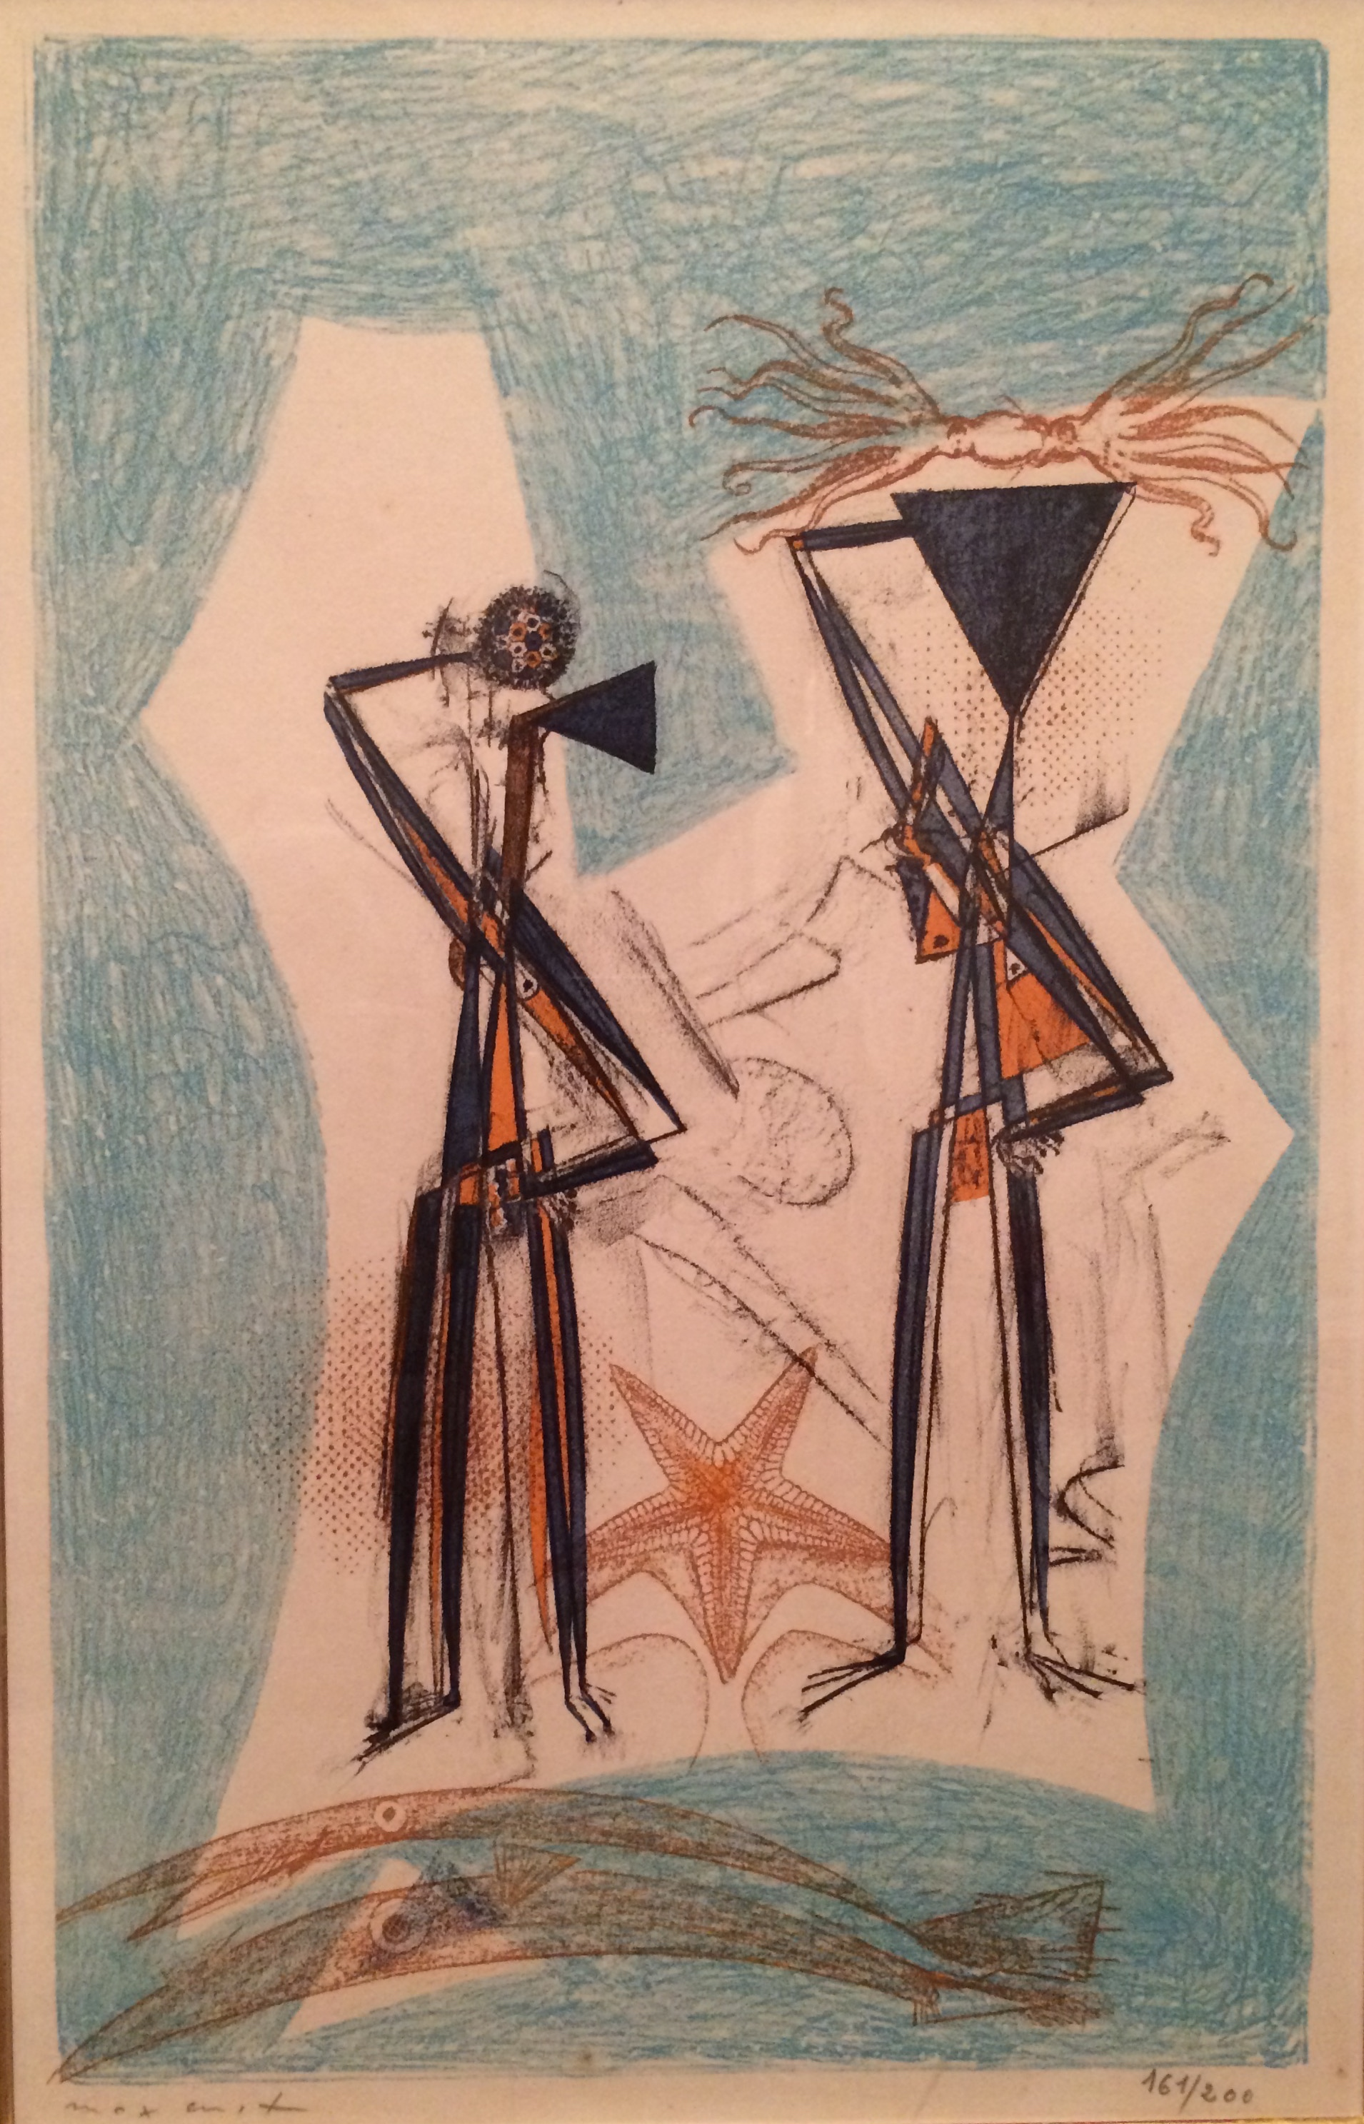

Max ERNST (1891-1976)
Étoile de mer
Lithograph, printed in color on Arches paper, 1950
One of 200 signed and numbered examples
Published by Guilde de la Gravure, Geneva/Paris
Image size: 16 ¾ x 10 ½ inches
Reference: Spies & Leppien 47

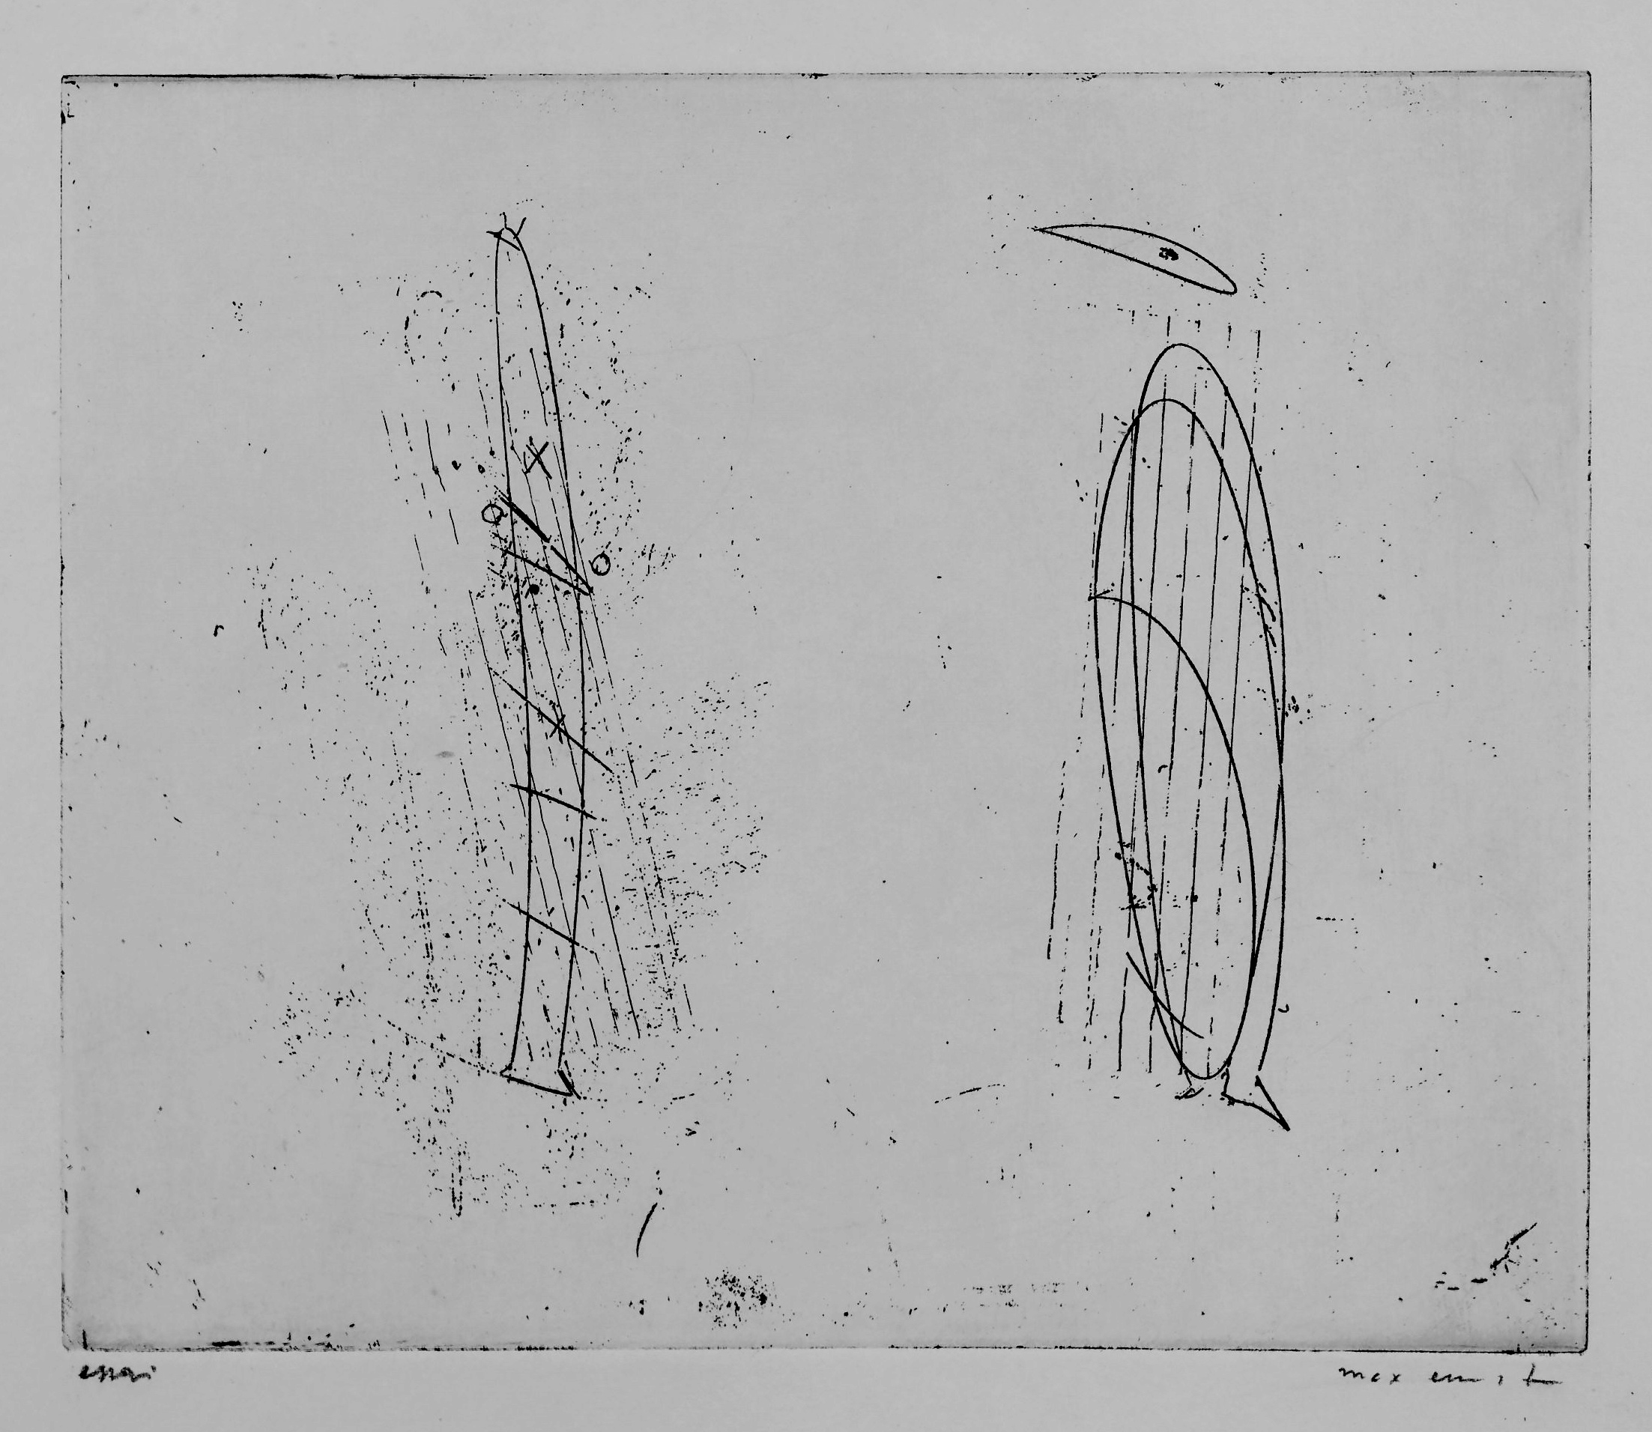
Max ERNST (1891-1976)
Untitled
Etching, printed in black on wove paper, 1959
Proof with wide margins, prior to its inclusion in the
de luxe copies of the book Le Poème de la femme 100 têtes
(edition of 50, published by Jean Hugues, Paris)
Signed and inscribed “essai” in pencil
Image size: 6 7/8 x 8 1/8 inches
Reference: Spies & Leppien 75

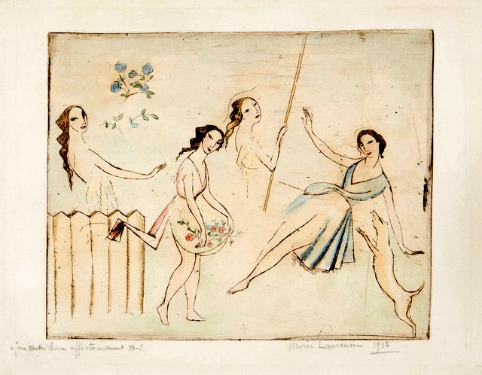
Marie LAURENCIN (1883-1956) Le Le Le Ballet
Etching with extensive hand-coloring in watercolor,
on laid paper, 1912
Signed, dated and dedicated in pencil:
“à Jane Martin bien affectueusement M-L”
Image size: 7 ¾ x 9 ¾ inches
Reference: Marchesseau 21

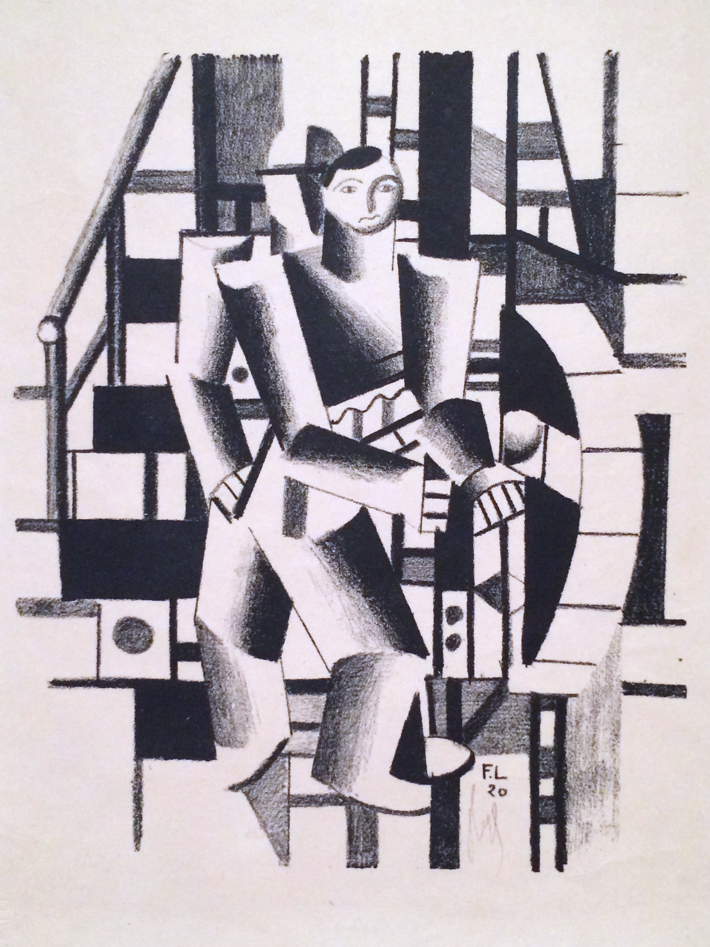
Fernand LÉGER (1881-1955)
Composition aux deux personnages
Lithograph, printed in black on wove paper, 1920
One of 125 signed examples from the portfolio
Die Schaffenden, no. 4, 1920
Published by Gustave Kiepenheuer, Weimar
Image size: 11 ¼ x 9 3/8 inches
Reference: Saphire 2

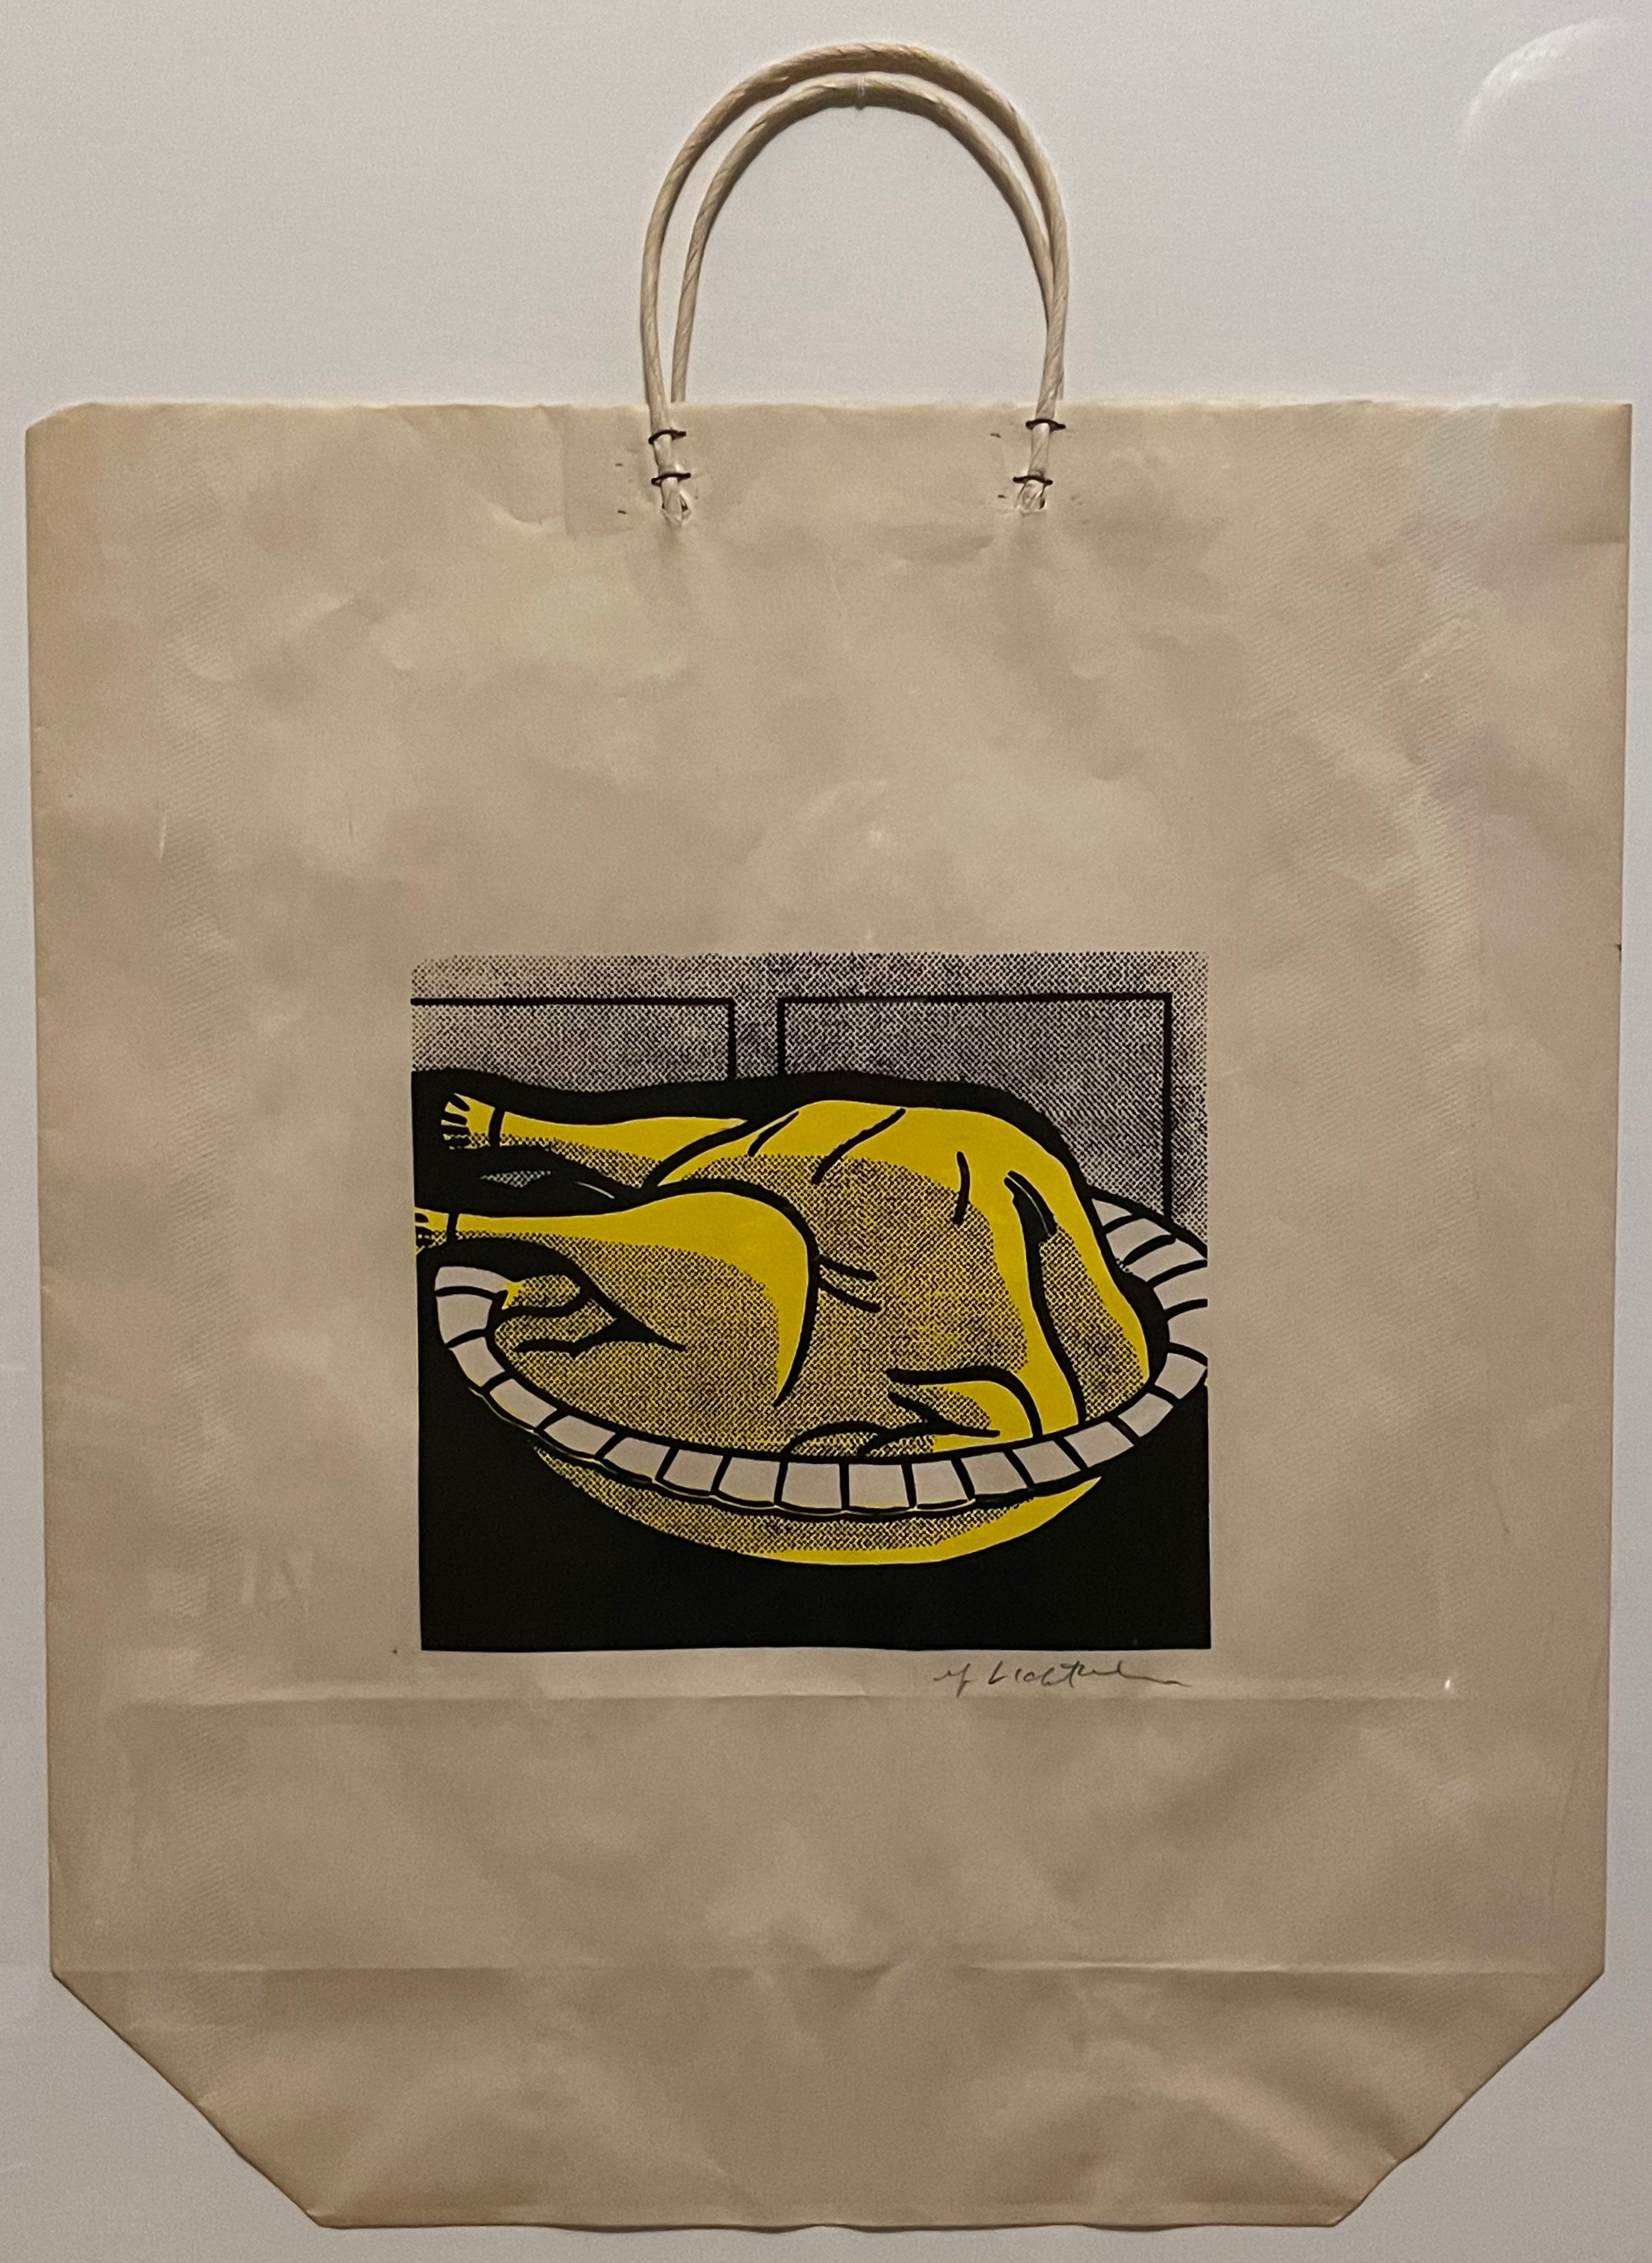
Roy LICHTENSTEIN (1923-1997)
Turkey Shopping Bag
1964
Screenprint in yellow and black, on wove paper bag with handles
One of approximately 125 signed examples
Co-published by Bianchini Gallery and Ben Brillo Editions, New York
Image size: 7 ¾ x 8 5/8 inches
Overall: 19 5/8 x 17 inches
Reference: Corlett Appendix 4

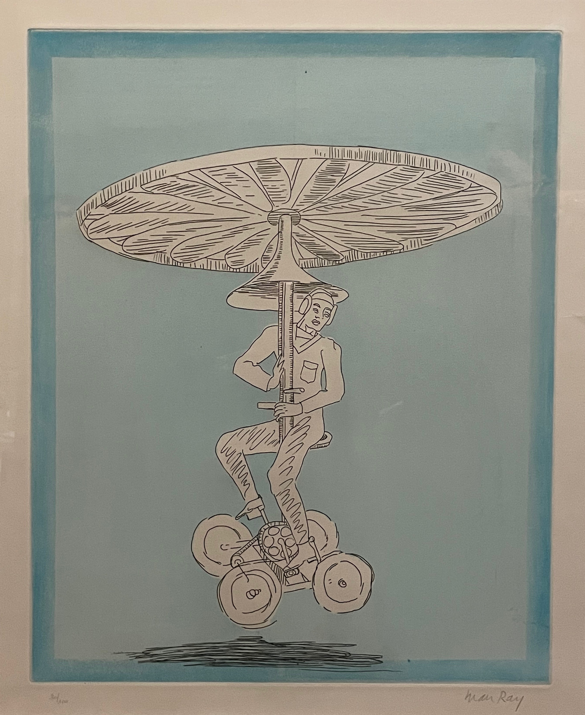

MAN RAY (1890-1976)
Manocopter
Etching and aquatint, printed in color on wove paper, 1972
One of 100 signed and numbered examples
Image size: 19 3/8 x 15 1/2 inches
Reference: Anselmino 7

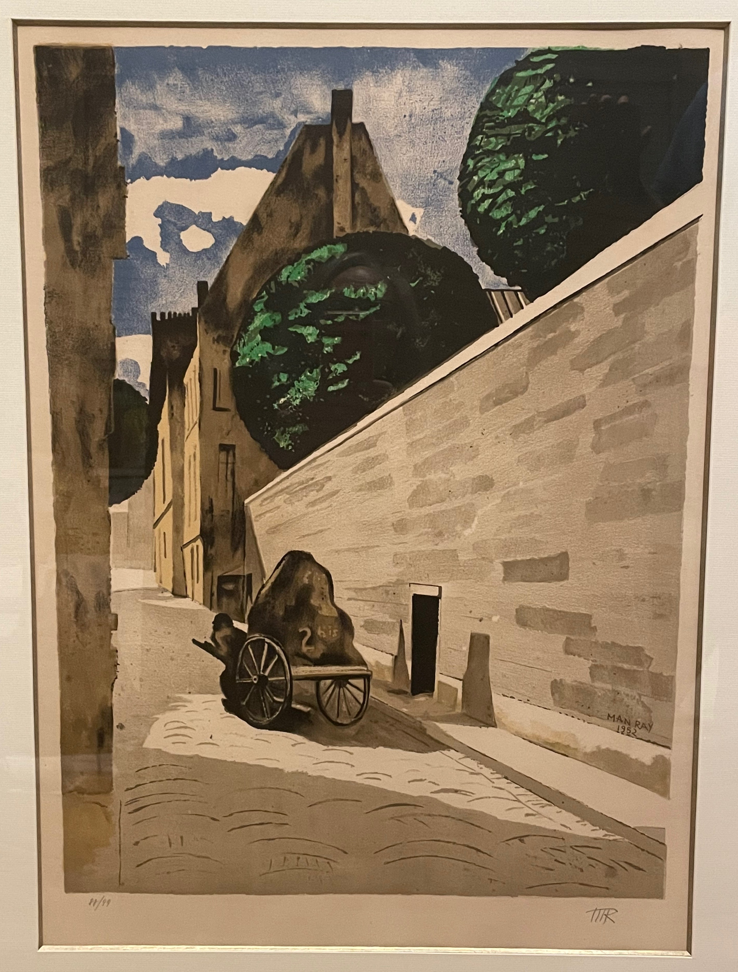
MAN RAY (1890-1976)
Rue Ferou
Lithograph, printed in color on Arches paper, 1974
One of 99 examples signed with the artist’s initials
Published by Astrid, Varese
Image size: 21 1/8 x 16 inches
Reference: Anselmino plate III

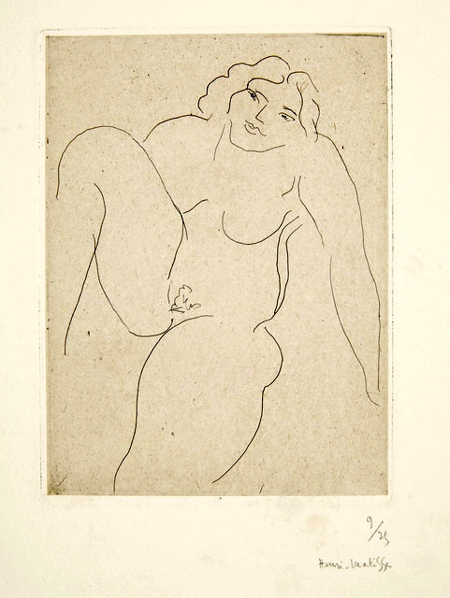

Henri MATISSE (1869-1954)
Nu de face, jambe droite repliée
Etching, printed in black on Chine appliqué paper, 1929
One of 25 signed and numbered examples
Image size: 5 ¾ x 4 ¼ inches
Reference: Duthuit 199

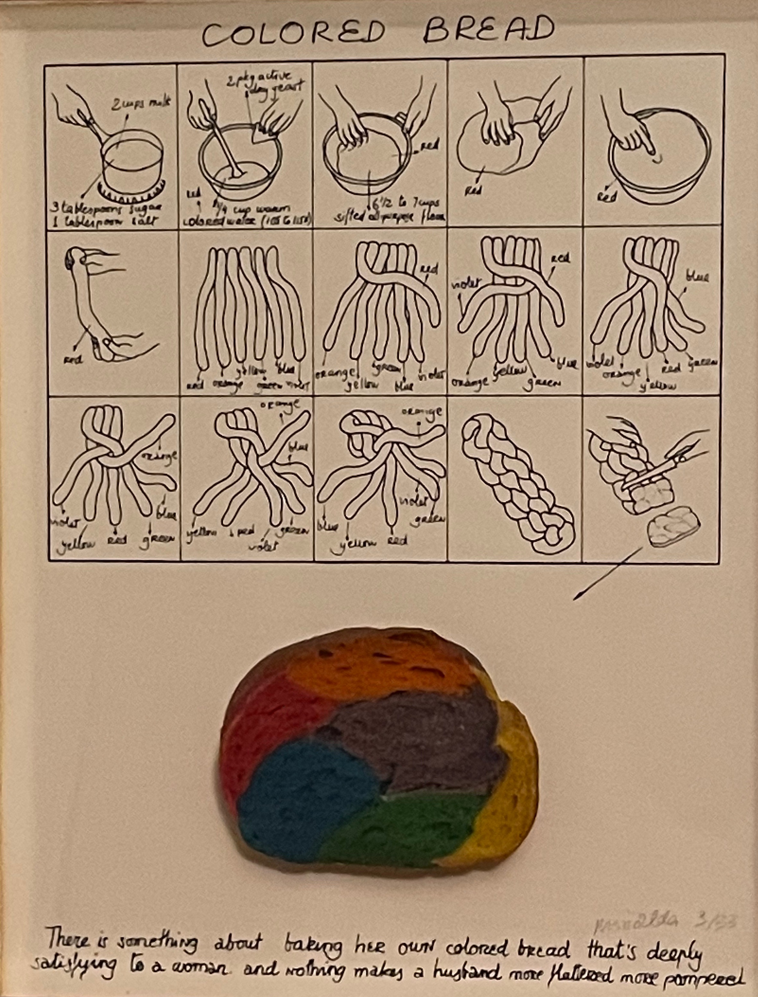

Antoni MIRALDA (born 1942)
Colored Bread
Offset printed text on light card stock with original object
affixed to the lower portion of the sheet, contained in a
plexiglas box designed by the artist, 1973
One of 33 signed and numbered examples
Box size: 14 5/16 x 11 3/8 x 2 ¾ inches

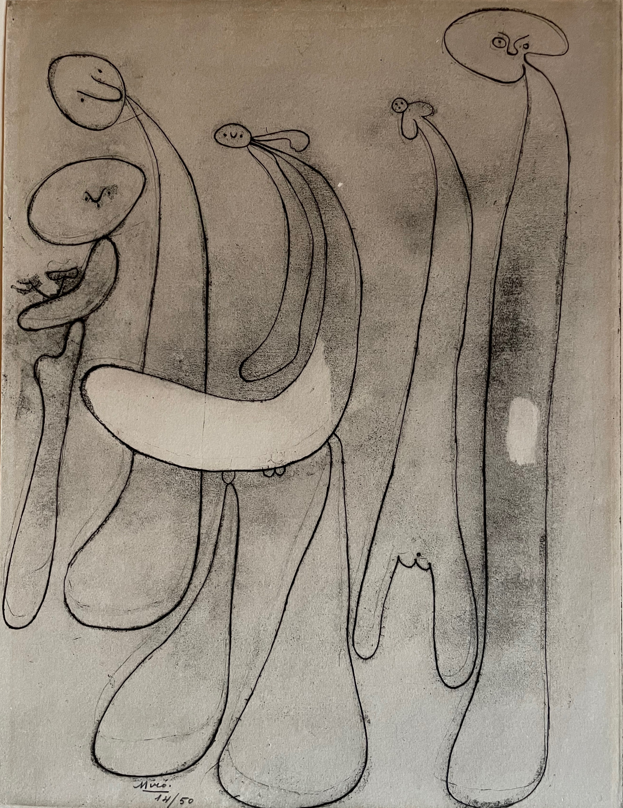

Joan MIRÓ (1893-1983)
Untitled from the album 23 Gravures
Etching, printed in black on wove paper, 1935
One of 50 signed and numbered examples from the album
with text by Anatole Jakovski
Published by Éditions Orobitz et Cie., Paris
Image size: 12 13/16 x 9 ¼ inches
Reference: Dupin 16; Cramer Books 3

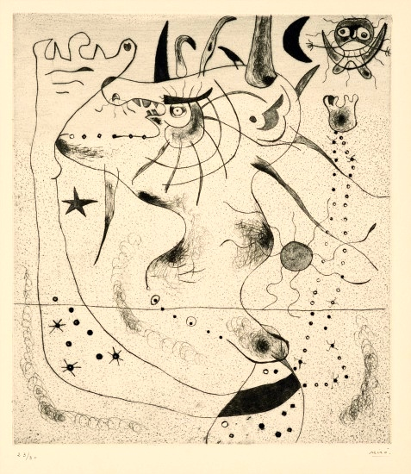

Joan MIRÓ (1893-1983)
L’Éveil du géant
Drypoint, printed in black, 1938
One of 30 signed and numbered examples
Co-published by Pierre Matisse and Pierre Loeb, Paris and New York
Image size: 10 3/8 x 9 1/8 inches
Reference: Dupin 26

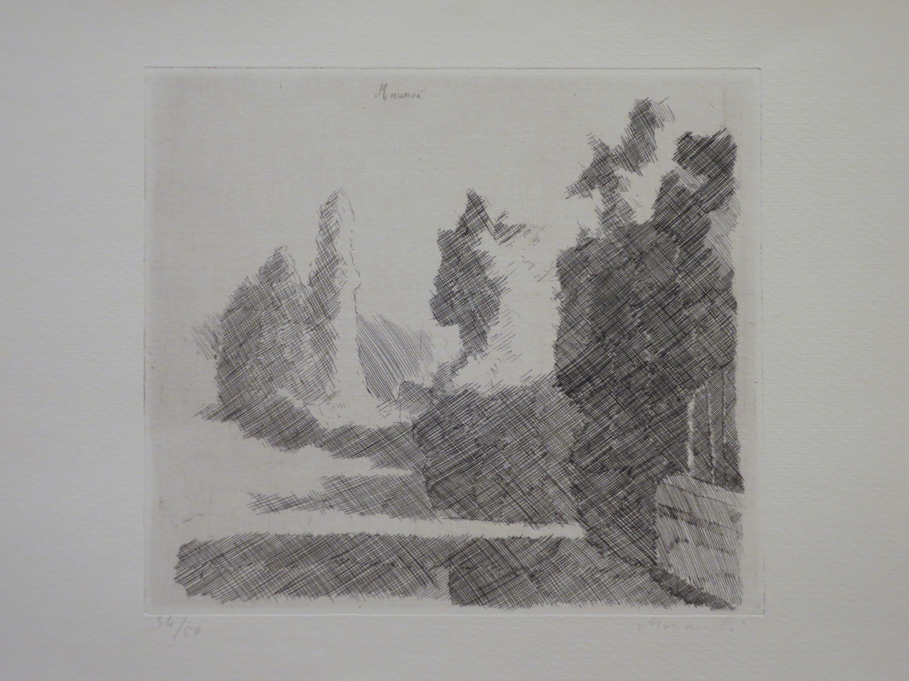

Giorgio MORANDI (1890-1964)
Paesaggio
Etching, printed in black, on wove paper, ca. 1930
One of 50 signed and numbered examples; this example
bearing dedication and second signature in pencil
at lower right
Image size: 6 7/8 x 7 5/8 inches
Reference: Vitali 77

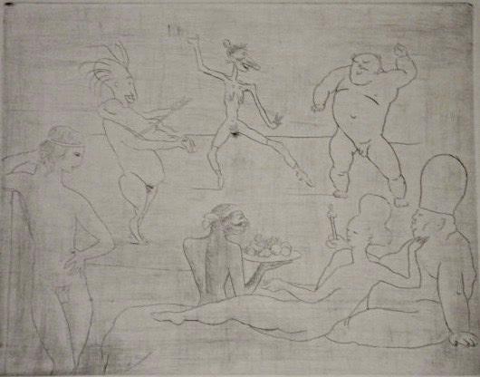
Pablo PICASSO (1881-1973)
La Danse from La Suite des Saltimbanques
Drypoint, printed in black on Van Gelder paper, 1905
One of 250 examples after steel-facing
Published by Ambroise Vollard, Paris, 1913
Image size: 7 ¼ x 9 1/8 inches
Note: the image depicts Salomé seated alongside
King Herod, for whom she will later perform an exotic
dance in exchange for the reward of John the Baptist’s head.
Reference: Baer 18; Bloch 15

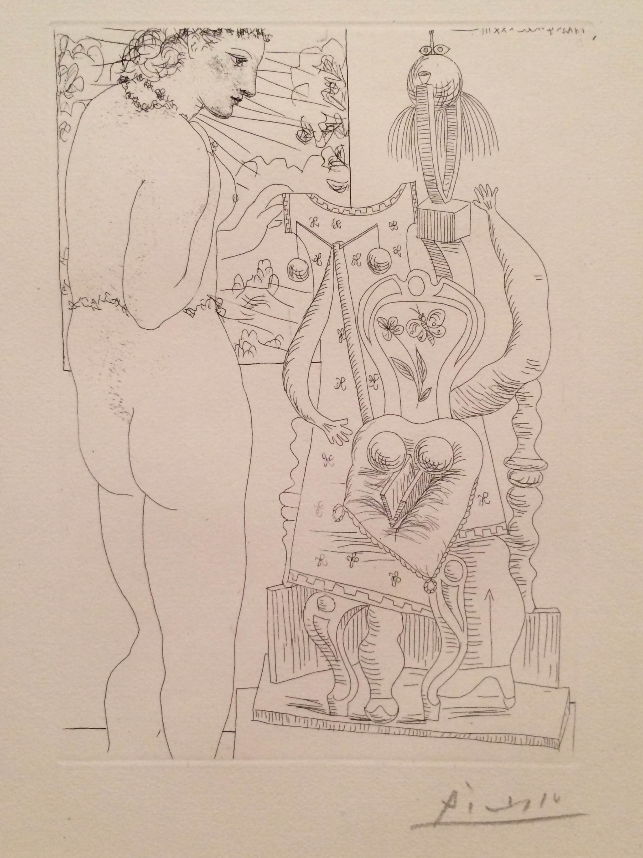

Pablo PICASSO (1881-1973)
Modèle et sculpture surréaliste (Marie-Thérèse)
Etching, printed in black on Montval paper with
the “Picasso” watermark, 1933
Signed example from the edition of 260 from La Suite Vollard
Published by Ambroise Vollard, Paris
Image size: 10 ½ x 7 5/8 inches
Reference: Bloch 187; Baer 346

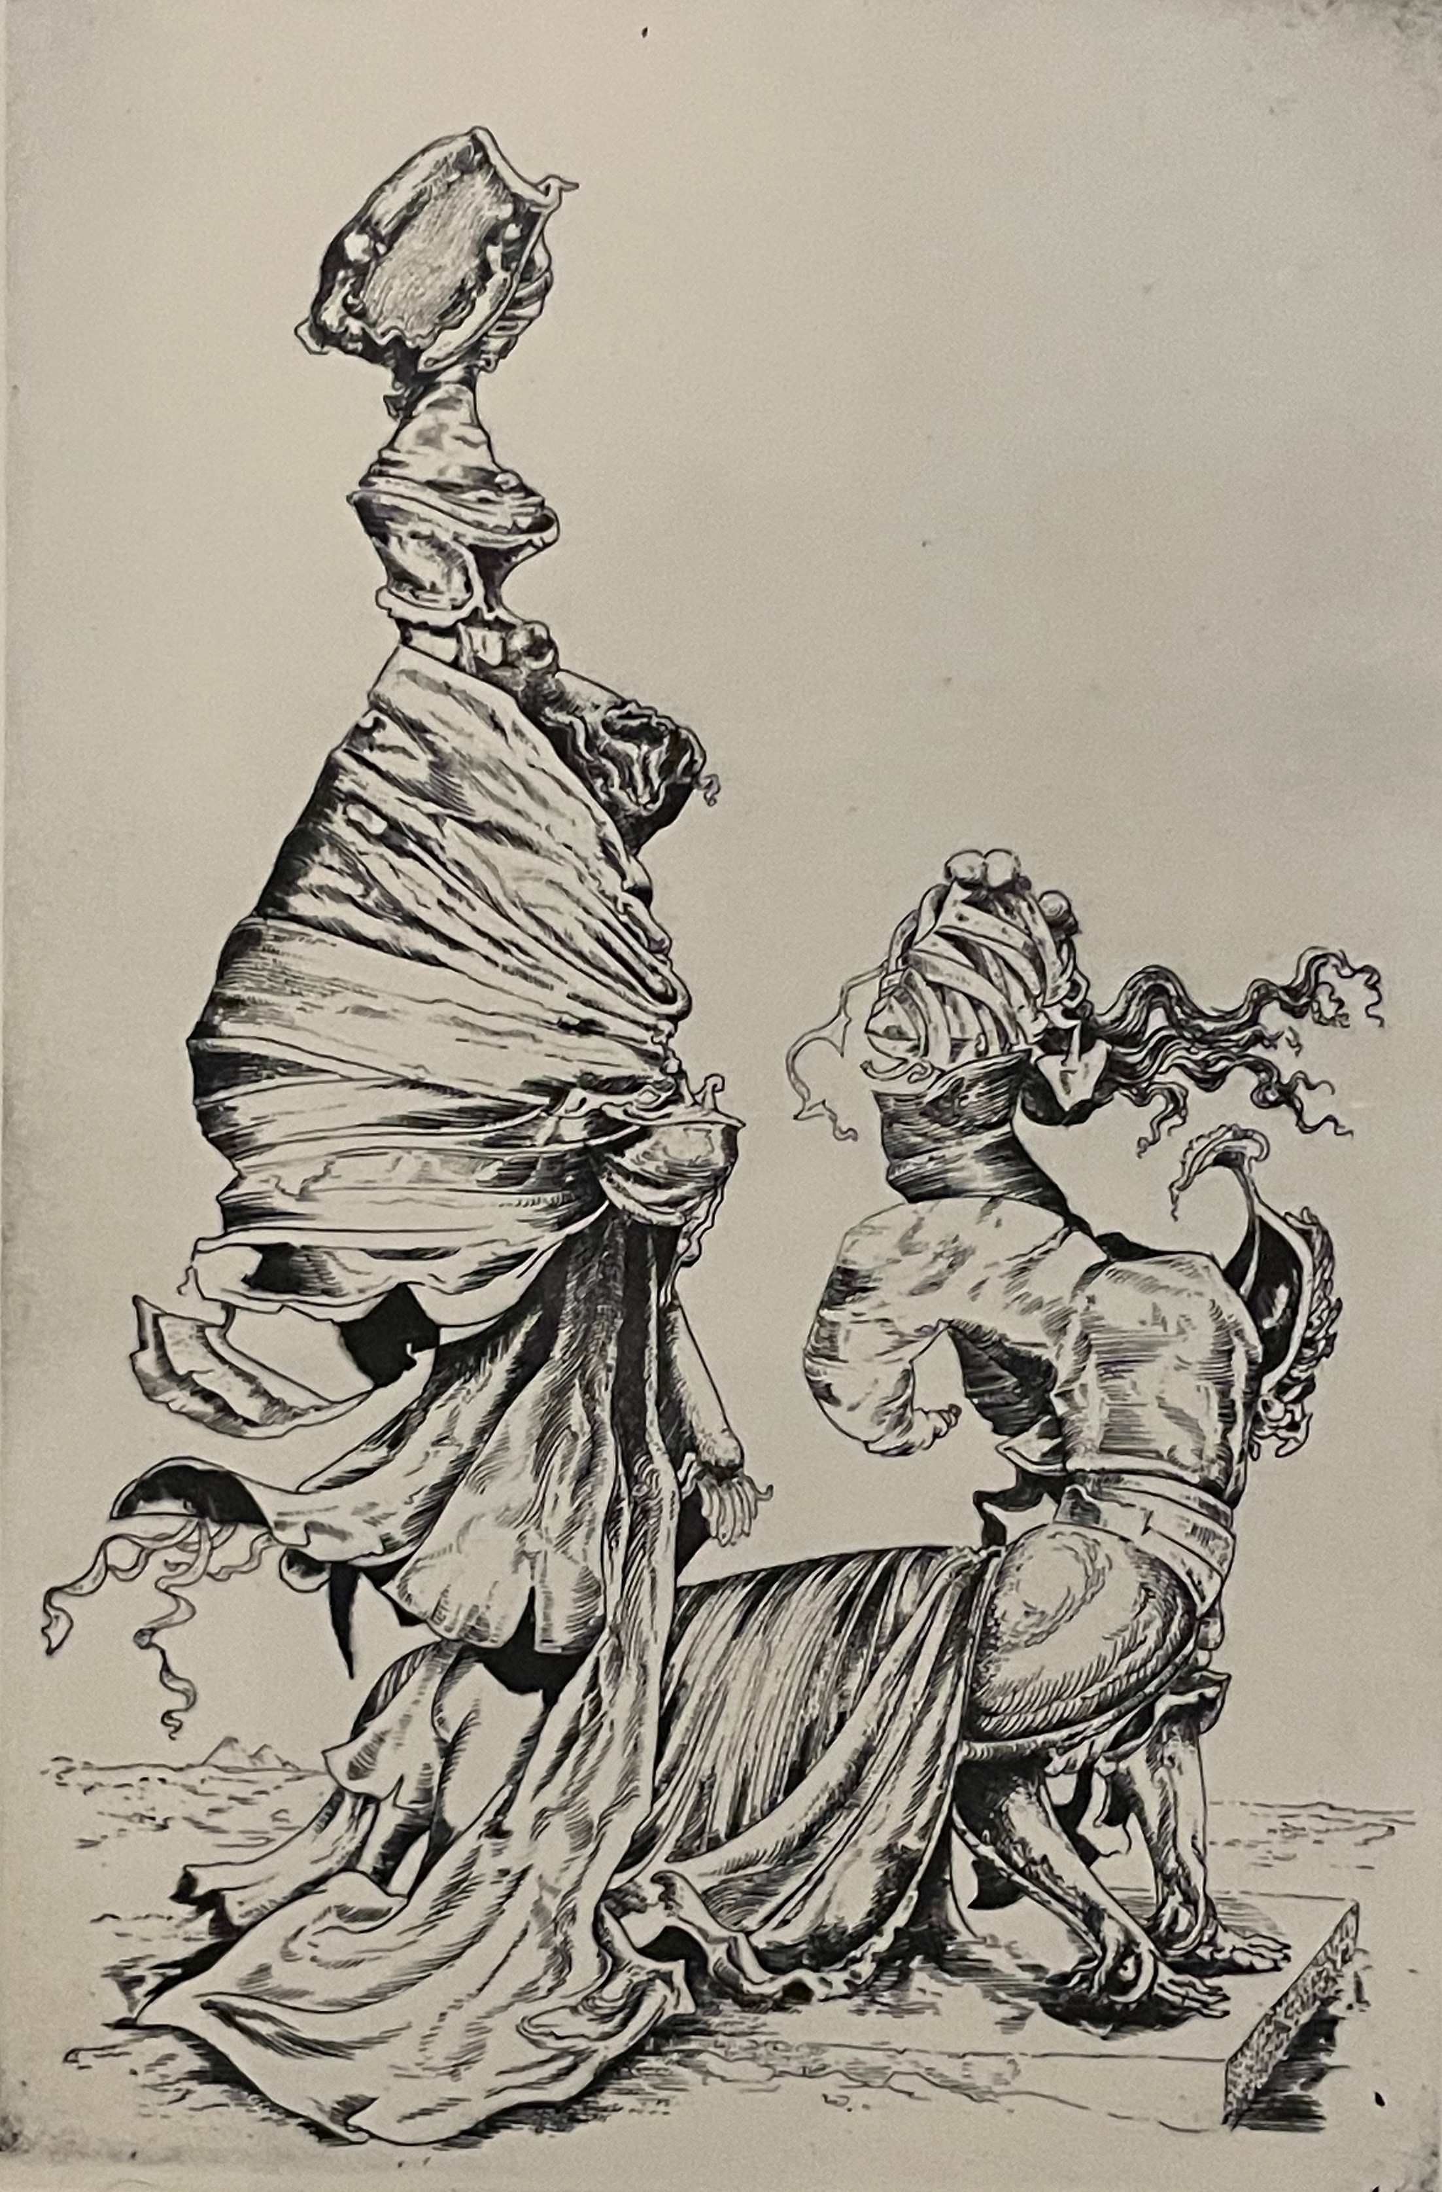

Kurt SELIGMANN (1900-1962)
The Sphinx, plate 1 (of six) from the series
The Myth of Oedipus
Etching, printed in black on J. Whatman paper, 1944
Signed proof separate from the edition of 50
Image size: 17 ¾ x 11 ¾ inches
Reference: Mason 117/I

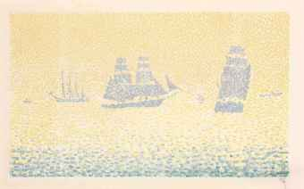
Paul SIGNAC (1863-1935)
Les Bateaux
Lithograph, printed in color on China paper, 1895
One of only 20 examples with remarque, signed,
prior to the edition of 40
Printed by Auguste Clot, Paris
Published by Gustave Pellet, Paris
Image size (without remarque): 9 ¼ x 15 3/8 inches
Reference: Kornfeld & Wick 13/II

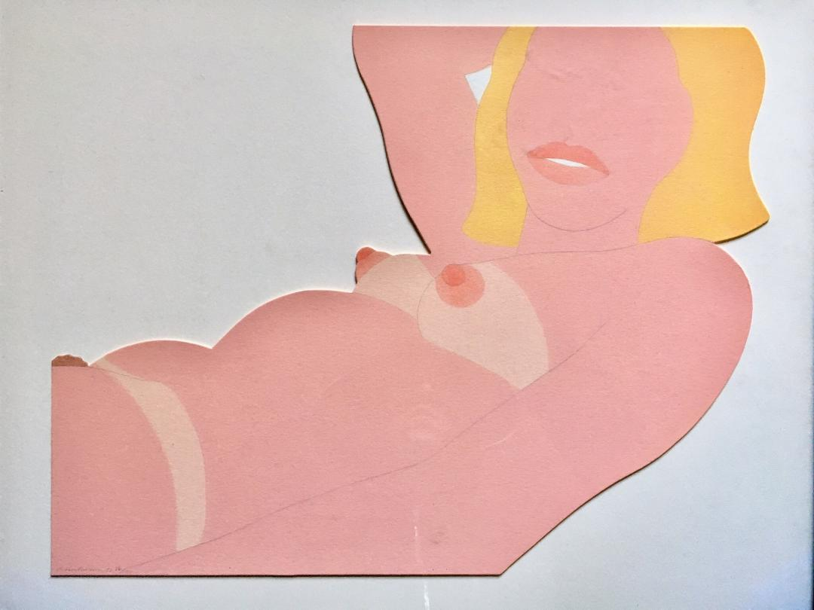
Tom WESSELMANN (1931-2017)
Great American Nude Cut Out
Thinned Liquitex paint and pencil in three colors
on die-cut museum board mounted to matboard
(as issued), 1970
One of 100 signed, dated and numbered examples,
each of which is a unique work, published by
the artist himself
Image size: 13 1/8 x 17 inches

