Works available by
15 February 2024

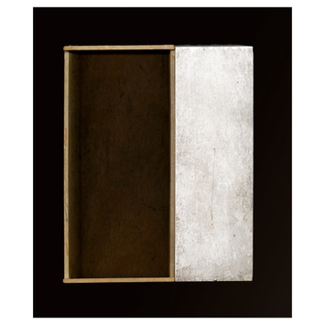 | Richard Fleischner  img.030, ed. 2/8, 2019  Dye-sublimation print  44 1/4 x 36 3/4 inches  Edition of 8 + 2 AP | $ 20,000
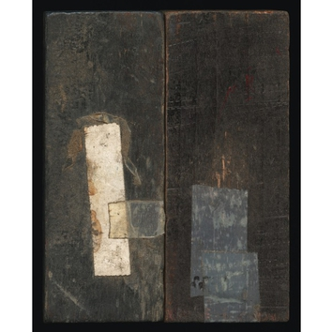 | Richard Fleischner  Untitled #1068 High Res, 2023-2024  Epson Ultrachrome Professional archival prints on Epson cold press natural paper  edition of 3 + 2 AP  70 7/8 x 57 1/2 inches | $ 42,000
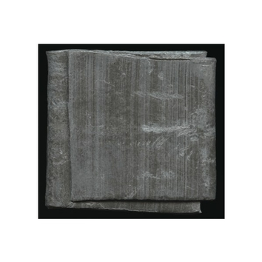 | Richard Fleischner  Untitled #1077 High Res, 2023-2024  Epson Ultrachrome Professional archival prints on Epson cold press natural paper  edition of 5 + 2 AP  18 x 19 1/16 inches  Framed dimensions 27 3/4 x 28 7/8 inches | $ 18,000
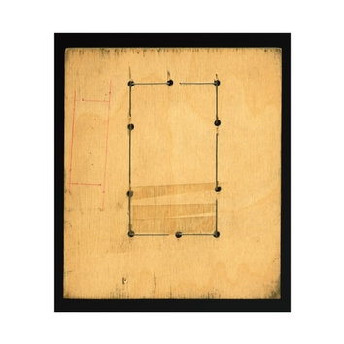 | Richard Fleischner  Untitled #923 High Res, 2023-2024  Epson Ultrachrome Professional archival prints on Epson cold press natural paper  edition of 5 + 2 AP  37 1/2 x 32 1/2 inches | $ 22,000
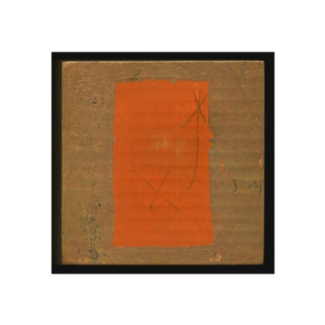 | Richard Fleischner  Untitled #1070 High Res, 2023-2024  Epson Ultrachrome Professional archival prints on Epson cold press natural paper  edition of 5 + 2 AP  18 x 18 1/16 inches  Framed dimensions 27 3/4 x 27 7/8 inches | $ 18,000
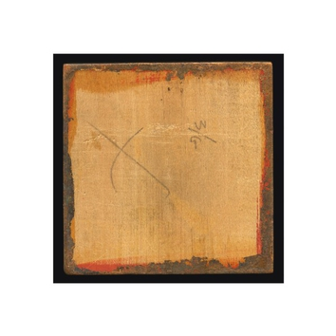 | Richard Fleischner  Untitled #1072 High Res, 2023-2024  Epson Ultrachrome Professional archival prints on Epson cold press natural paper  edition of 5 + 2 AP  18 x 18 1/16 inches  Framed dimensions 27 3/4 x 27 7/8 inche | $ 18,000
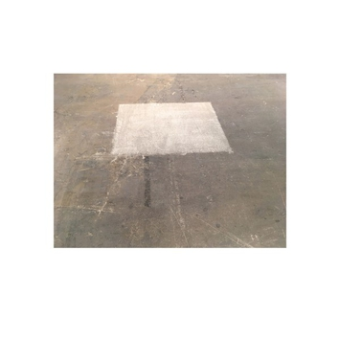 | Richard Fleischner  Floating Square 2020 High Res, 2023-2024  Epson Ultrachrome Professional archival prints on Epson cold press natural paper  edition of 5 + 2 AP  8 1/2 x 11 inches  Framed dimensions 14 3/8 x 16 1/2 inches | $ 12,000
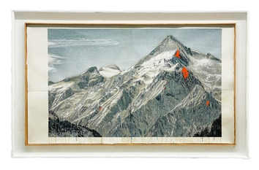 | Doug and Mike Starn  MTN 621, ed. 2/3, 2021-2022  Acrylic paint on Ultrachrome K3 Epson ink jets prints on gelatin hand-coated Zerkall paper, scotch tape  Framed dimensions 59 x 96 inches | $ 75,000
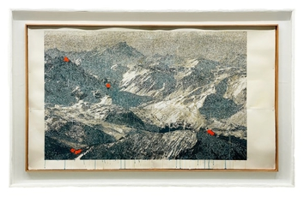 | Doug and Mike Starn  MTN 123 CROP 2, ed. 1/3, 2021-2022  Acrylic paint on Ultrachrome K3 Epson ink jet print on gelatin hand-coated Zerkall paper, Scotch tape  35 x 58 1/2 inches  Framed dimensions 41 x 65 inches | $ 35,000
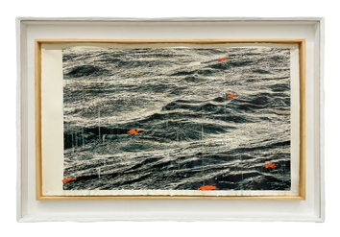 | Doug and Mike Starn  SCP 2228A, ed. 2/9, 2021-2022  Acrylic paint on Ultrachrome K3 Epson ink jet print on gelatin hand-coated Zerkall paper, Scotch tape  19 x 32 inches  Framed dimensions 24 1/2 x 36 1/2 inches | $ 18,000
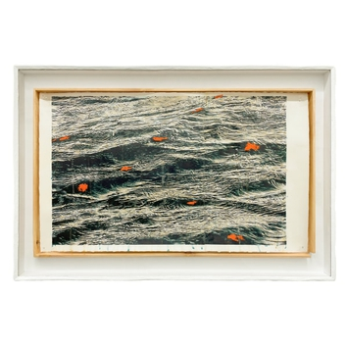 | Doug and Mike Starn  SCP 2228B ed. 3/9, 2021-2022  Acrylic paint on Ultrachrome K3 Epson ink jet print on gelatin hand-coated Zerkall paper, Scotch tape  19 x 32 inches  Framed dimensions 24 1/2 x 36 1/2 | $ 18,000
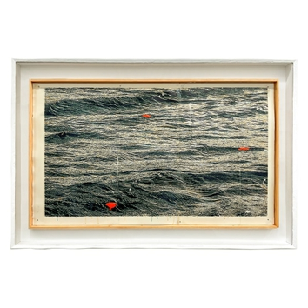 | Doug and Mike Starn  SCP 22293B, ed. 3/9, 2021-2022  Acrylic paint on Ultrachrome K3 Epson ink jet print on gelatin hand-coated Zerkall paper, Scotch tape  19 x 32 inches  Framed dimensions 24 1/2 x 36 1/2 inches | $ 18,000
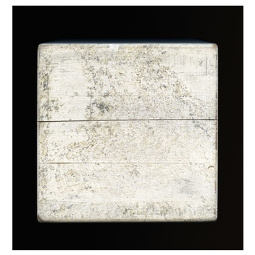 | Richard Fleischner  img.496, ed. 1/8, 2020  Dye-sublimation print  38 x 35 3/4 inches  Edition of 8 + 2 AP | $ 20,000
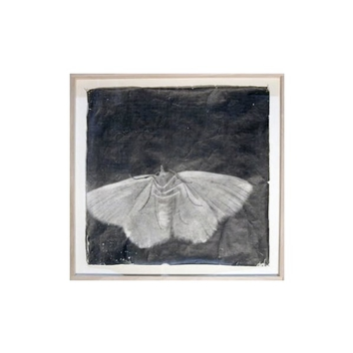 | Doug and Mike Starn  Attracted to Light 37, ed. 4/10, 2002-2003  Toned Silver Print on Thai Mulberry Paper  20 x 20 inches  Framed dimensions 26 x 26 inches | $ 12,500
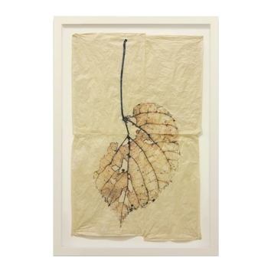 | Doug and Mike Starn  Black Pulse 6, AP1, 2000-2015  Epson K3 Ultrachrome inkjet print with Albumen and encaustic on Gampi paper, Scotch tape, and glue  Framed dimensions 49 1/2 x 34 1/2 inches | $ 26,500
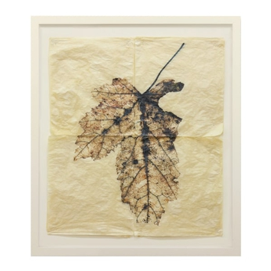 | Doug and Mike Starn  Black Pulse 3, AP2, 2000-2015  Epson K3 Ultrachrome inkjet print with Albumen and encaustic on Gampi paper, Scotch tape, and glue  Framed dimensions 41 1/2 x 34 1/2 inches  36 x 29 inches | $ 29,000

